**PIZZA SALES SQL QUERIES**

**A. KPI’s**

**1. Total Revenue:**

select round(sum(total_price),2) total_revenue from pizza;

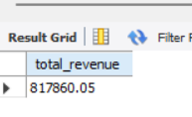

**2. Average Order Value**

select round(sum(total_price)/count(distinct(order_id)),2) as avg_order_value from pizza;

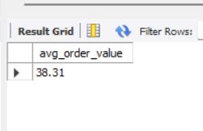

**3. Total Pizzas Sold**

select sum(quantity) Total_pizza_sold from pizza;

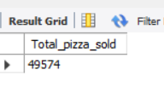

**4. Total Orders**

select count(distinct(order_id)) Total_Orders from pizza;

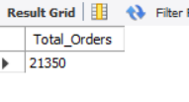

**5. Average Pizzas Per Order**

select round(sum(quantity)/count(distinct(order_id)),2) as Average_Pizzas_Per_Order from pizza;

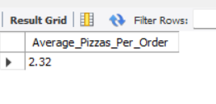

**B. Hourly Trend for Total Pizzas Sold**

select time_format(order_time,"%H") hours, sum(quantity) total_sold from pizza group by 1 order by 2 ;

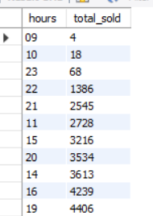

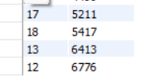

**C. Weekly Trend for Orders**

select date_format(order_date,"%v") weeks, count(distinct(order_id)) from pizza group by 1 order by 1 ;

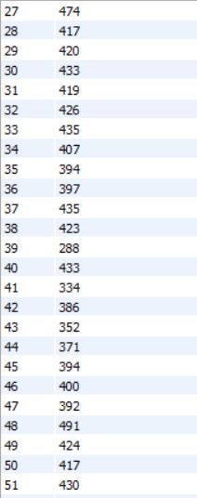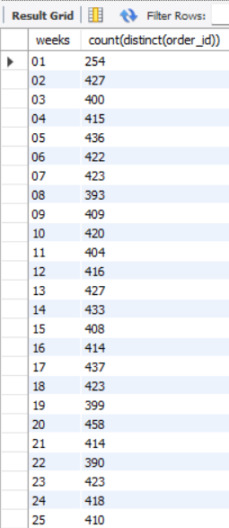



**D. % of Sales by Pizza Category**

select pizza_category, round(sum(total_price),2) total_revenue,round(sum(total_price),2) *100/(select round(sum(total_price),2) from pizza) pct from pizza group by 1;

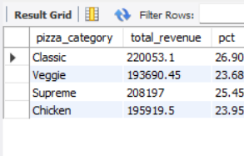

**E. % of Sales by Pizza Size**

select pizza_size, round(sum(total_price),2) total_revenue,round(sum(total_price),2) *100/(select round(sum(total_price),2) from pizza) pct from pizza group by 1;

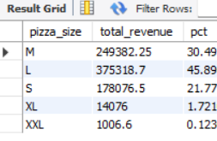

**F. Total Pizzas Sold by Pizza Category**

select pizza_category, sum(quantity) total_sales from pizza group by 1;

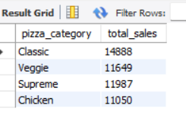

**G. Top 5 Pizzas by Revenue**

select pizza_name ,sum(total_price) from pizza group by 1 order by 2 desc limit 5 ;

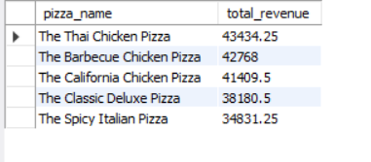

**H. Bottom 5 Pizzas by Revenue**

select pizza_name ,sum(total_price) total_revenue from pizza group by 1 order by 2 limit 5 ;

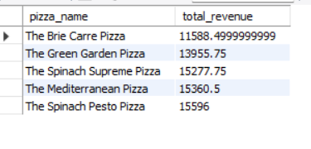

**I. Top 5 Pizzas by Quantity**

select pizza_name ,sum(quantity) total_pizza_sold from pizza group by 1 order by 2 desc limit 5 ;

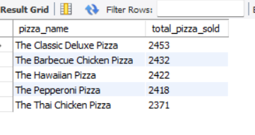

**J. Bottom 5 Pizzas by Quantity**

select pizza_name ,sum(quantity) total_pizza_sold from pizza group by 1 order by 2 limit 5 ;



**K. Top 5 Pizzas by Total Orders**

select pizza_name ,count(distinct(order_id)) total_order from pizza group by 1 order by 2 desc limit 5 ;

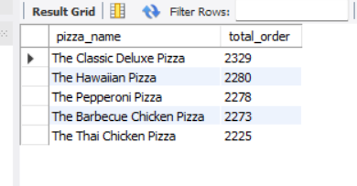

**L. Borrom 5 Pizzas by Total Orders**

select pizza_name ,count(distinct(order_id)) total_order from pizza group by 1 order by 2 limit 5

